**Experiment no.6**

**Aim:-Edit/Compile/Run a program to display the Floyd Triangle’s.**

**Program-A)**

n=int(input("Enter the total Number of Rows:-"))  
count=1  
for i in range(1,n+1):  
 for j in range(1,i+1):  
 print(count,end= ' ')  
 count=count+1  
 print()

**output:-**

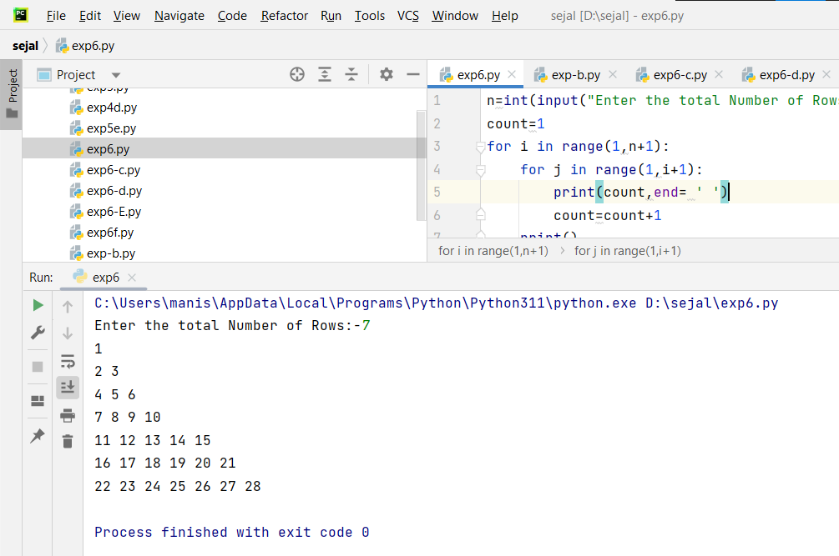

**Program-B)**

n=int(input("Enter the total Number of Rows:-"))  
count=1  
i=1  
while(i<=n):  
 j=1  
 while(j<=i):  
 print(count,end=' ')  
 count=count+1  
 j=j+1  
 i=i+1  
 print()

**output:-**

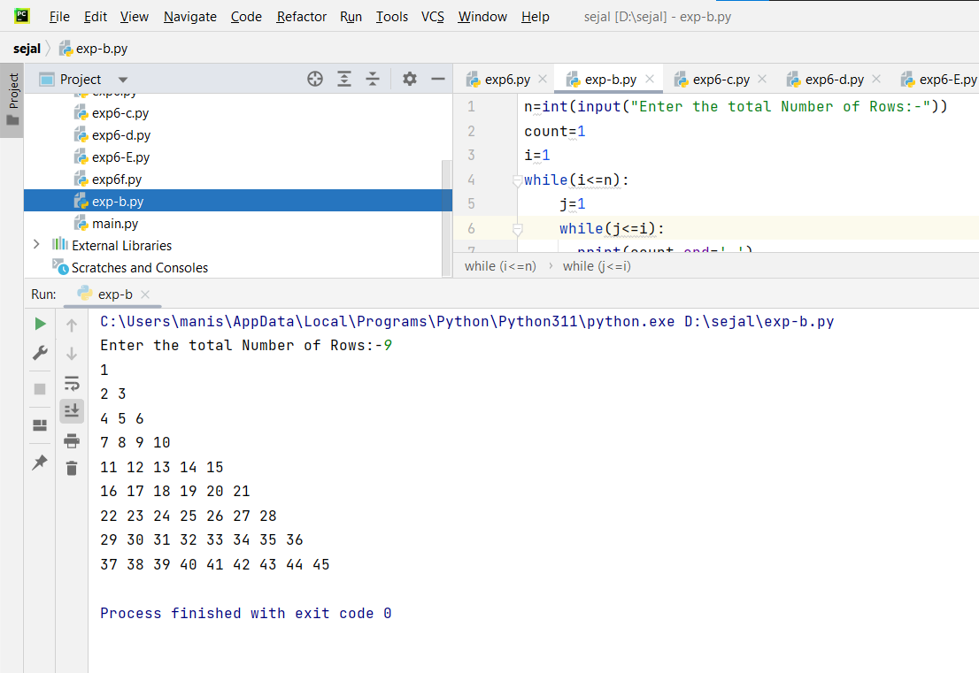

**Program-C)**

print("Enter the Number of Rows:",end="")  
row=int(input())  
num=1  
for i in range(row):  
 for j in range(i+1):  
 print(num,end=' ')  
 num=num+1  
 print()

**output:-**

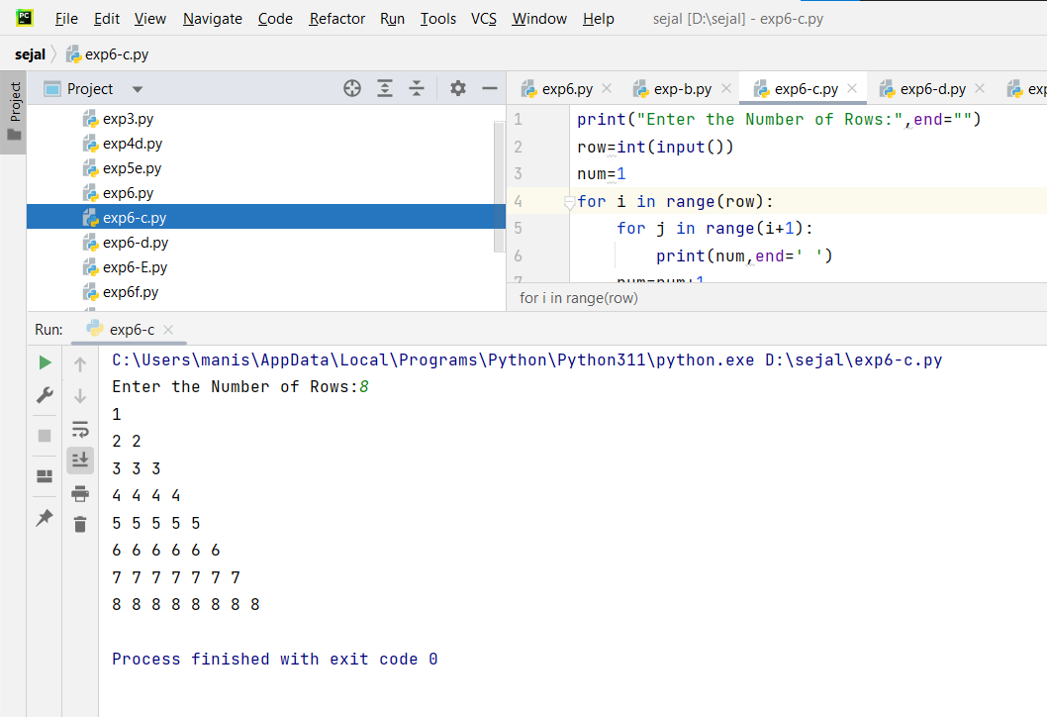

**Program-D)**

print("Enter the Number of Rows:",end="")  
row=int(input())  
num=1  
i=0  
while i<row:  
 j=0  
 while j<i+1:  
 print(num,end=' ')  
 num=num+1  
 j=j+1  
 print()  
 i=i+1

**output:-**

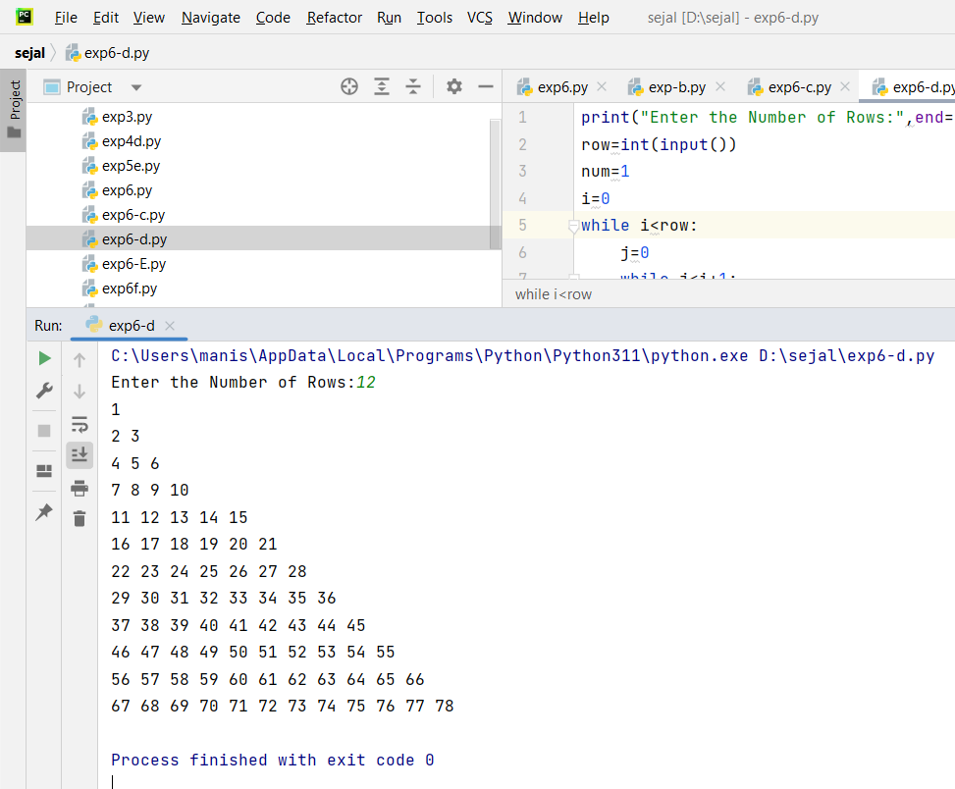

**Program-E)**

rows=int(input("Enter Triangle Numbers Pattern Rows= "))  
  
for i in range(1,rows+1):  
 for j in range(rows,i,-1):  
 print(end=' ')  
 for k in range(1,i+1):  
 print(k,end=' ')  
 print()

**output:-**

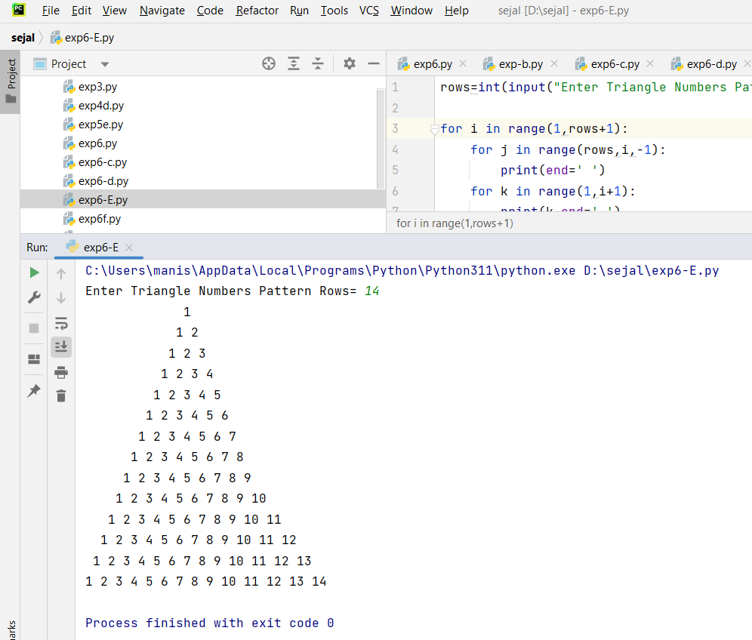

|  |  |  |  |
| --- | --- | --- | --- |
| **Practical Performance**  **(4)** | **Writeup & Oral**  **(4)** | **Attendance**  **(2)** | **Total**  **(10)** |
|  |  |  |  |